**“Contact Book App”**

***A***

***Project Report***

*submitted in partial fulfillment of the*

*requirements for the award of the degree of*

**BACHELOR OF TECHNOLOGY**

**in**

**COMPUTER SCIENCE & ENGINEERING**

**by**

|  |  |
| --- | --- |
| **Name** | **Roll No.** |
| **Shubh Gaur** | **R-164218071** |
| **Shreya Sharma** | **R-164218070** |
| **Khush Raghav Nanda** | **R-164218088** |
| **Ishika Agrawal** | **R-164218097** |

***under the guidance of***

**Dr. Varun Sapra**



**Department of Systematics**

**School of Computer Science**

**University of Petroleum & Energy Studies**

**Bidholi, Via Prem Nagar, Dehradun, UK**

**July,2021**



**CANDIDATE’S DECLARATION**

I/We hereby certify that the project work entitled **“ Contact Book App”** in partial fulfilment of the requirements for the award of the Degree of BACHELOR OF TECHNOLOGY in COMPUTER SCIENCE AND ENGINEERING with specialization in Internet Of Things And Smart Cities submitted to the Department of Systemics, School of Computer Science, University of Petroleum & Energy Studies, Dehradun, is an authentic record of my/ our work carried out during a period from **7 June**, **2021**to **22 July**, **2021** under the supervision of **Dr. Varun Sapra, Assistant Professor and UPES**

The matter presented in this project has not been submitted by me/ us for the award of any other degree of this or any other University.

**Shubh Gaur R-164218071**

**Shreya Sharma R-164218070**

**Khush Raghav Nanda R-164218088**

**Ishika Agrawal R-164218097**

Student Name Roll no

This is to certify that the above statement made by the candidate is correct to the best of my knowledge.

Date: 11-08-2021 **Mr. Varun Sapra**

Project Guide

**Dr. Neelu Jyoti Ahuja**

HOD – Internet of Things and Smart City

Department of Systemics, SoCS

University of Petroleum & Energy Studies

Dehradun – 248007 (Uttarakhand)

**ACKNOWLEDGEMENT**

We wish to express our deep gratitude to our guide **Dr. Varun Sapra** for all advice, encouragement and constant support he has given us throughout our project work. This work would not have been possible without his support and valuable suggestions.

We sincerely thanks to our respected **Mrs.** **Neelu Jyoti Ahuja,** **Head Department of Systemics,** for his great support in doing our project in **Contact Book App.**

We are also grateful to,Dean Dr. Priyadarshan Patra, SoCSE, UPES for giving us the necessary facilities to carry out our project work successfully. We also thanks to our Course Coordinator, Dr. Rohit Tanwar and our Activity Coordinator (NAME) for providing timely support and information during the completion of this project.

We would like to thank all our **friends** for their help and constructive criticism during our project work. Finally, we have no words to express our sincere gratitude to our **parents** who have shown us this world and for every support they have given us.

|  |  |  |  |  |
| --- | --- | --- | --- | --- |
| **Name** | **Shubh Gaur** | **Shreya Sharna** | **Khush Raghav Nanda** | **Ishika Agrawal** |
| **Roll No.** | **R-164218071** | **R-164218070** | **R-164218088** | **R-164218097** |

**Abstract:**

Contact book is a daily use kind of application. With a contact book, you can store and manage the contact information. The project demonstrates the creation of a Graphical User Interface of the contact book, using the **Tkinter,** Tkinter is a standard python GUI toolkit which also enabled with a powerful OOPS interface to GUI toolkit. This application uses various Python and Tkinter functions to generate Treeview structure, labels, buttons and file dialog box etc.

In this project we are using **SQLite database** which is python build-in database. It has almost all features of Relational database, it also provides a SQL interface a self-contained, serverless, zero-configuration, transactional SQL database engine. It is a database, which is zero-configured, which means like other databases you do not need to configure it in your system. SQLite engine is not a standalone process like other databases, you can link it statically or dynamically as per your requirement with your application. SQLite accesses its storage files directly.

This Contact Book is providing easy access and maintains their contacts. We also enable with a feature of Import and Export data if user want to share its all contact to another device can did by using Export contact function or if due any problem all contact is deleted then user is able to import bulk contacts using Import contact function.

Collecting, maintaining, and using identification information about clients sometimes becomes difficult when the data is too large. Without a Standardized, systematic way to store and retrieve information searching for a particular record becomes a big task. By using this contact book app accessing, updating and deleting a particular or multiple record becomes easy.

# TABLE OF CONTENTS

1. Introduction
2. Problem Statement
3. Objective
4. Methodology
5. Implementation
6. Use Case
7. Flowchart
8. DFD
9. Output
10. Conclusion
11. References

**Introduction:**

A contact book or address book is an application that stores the information like name, address, contact no email id and image of a person that you can save in contact book app and also update and delete the contact.Proper storage of contact information is very necessary. Data is an important asset in any person, business, and for some organization it’s one of the most important assets. That’s why a storage of contact information must be robust and reliable.

Electronically information storage makes the data you’re storing easy to search and use. When you’re storing your data electronically instead of on paper, it’s simple to analyze the data and leverage it for your business. It’s also easy to make backup copies without taking up huge amounts of time and space.

The objective of this project is to create Contact book app in which the user can add contact information, add image to contact information which help to remember a person, update it, delete the existing contacts, view existing contact and import and export their contacts.

In this python project, using Treeview widget to access contacts and the user has to click on a button which functions the user wants to edit e.g. – To edit a contact, the user has to first select a contact then click on view button then edit the contact and then click on edit button. To add a new contact user has to click on the add button.

This GUI based project which provides the simplest management of contact details. In order to run the project, you must have installed [Python](https://www.python.org/downloads/release/python-365/), on your PC.

**Features:**

1. Add Contacts
2. List Contacts
3. Update Contacts
4. Delete Contacts
5. Import/Export of csv file
6. Adding photo to the contact entry
7. Search Contact

**Problem Statement:**

Since contacts is an important asset in any individual person, businesses and organizations. The way we store our contact information plays a major role in how easy it is to access, use, and keep secure. Therefore, there is a need to develop a system where we can easily store and retrieve information.

**Objective:**

We have to enable a contact book app with an SQLite database. This database consists of details about the clients: First Name, Last Name, Phone Number, Email and Image icon.

It should provide a feature like:

1. Add Contacts
2. List Contacts
3. Update Contacts
4. Delete Contacts
5. Import/Export of csv file
6. Set Icon of individual contact

**METHODLOGY:**

We divide our whole Implementation in seven modules:

**Module 1:**

Design the Features looks and working of functions.

**Module 2:**

Create a GUI using Tkinter modules and widgets.

**Module 3:**

Create an SQLite Database connection and create a table according to required fields.

**Module 4:**

Import PIL library and file dialog widget which helps to embed image in python Treeview widget.

**Module 5:**

Create a user define functions which helps to perform operation and data sharing and importing functions.

**Module 6:**

Convert .py python file into standalone .exe executable file.

**Module 7:**

Testing and improve the features of app.

**Use Case Diagram:**

**Actor:** User, System

* User Add Data
* User Add Image (Optional)
* User Update Contact.
* User Delete Contact.
* User Import/Export Contact data.
* User can search contact.
* System Sort and update entries and show on Treeview.

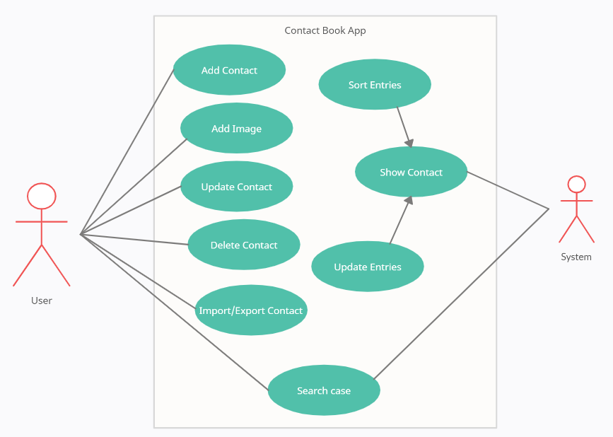

**Flowchart:**

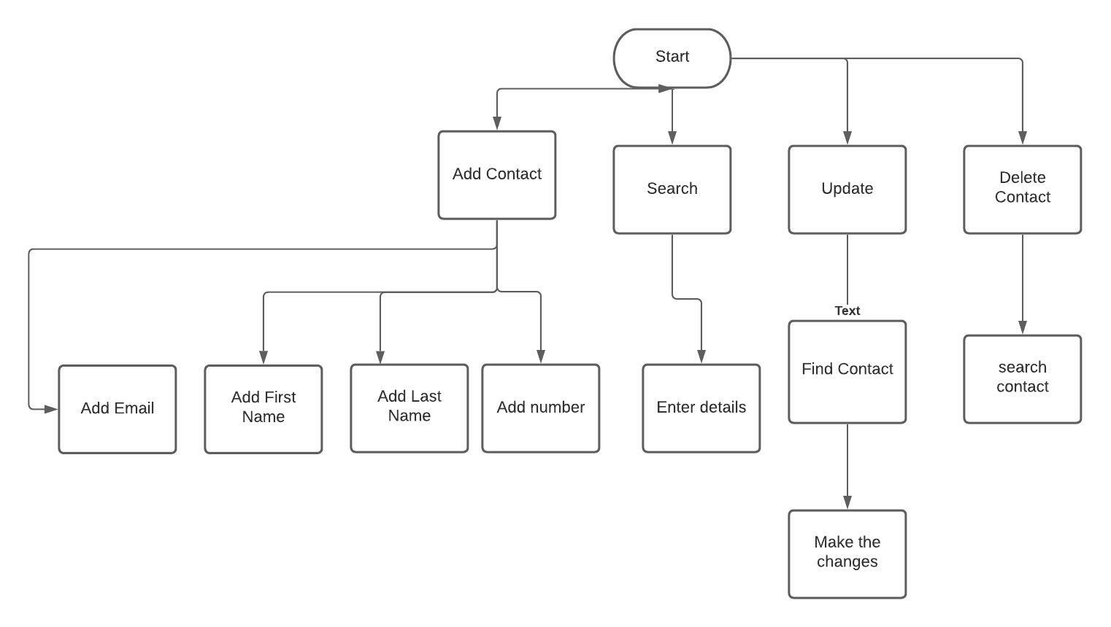

**DFD:**

* External entity: User and Contact Book app
* Here the user can add, update, Delete, Search and Import/Export User name, phone no. and Email are stored in database

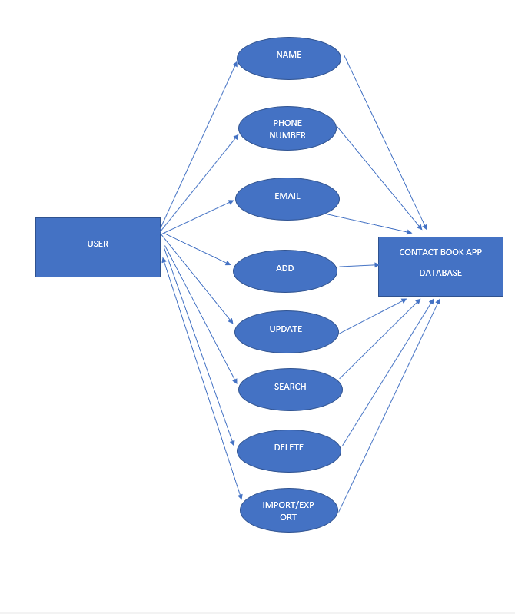

**Outputs:**

**Main Window:**

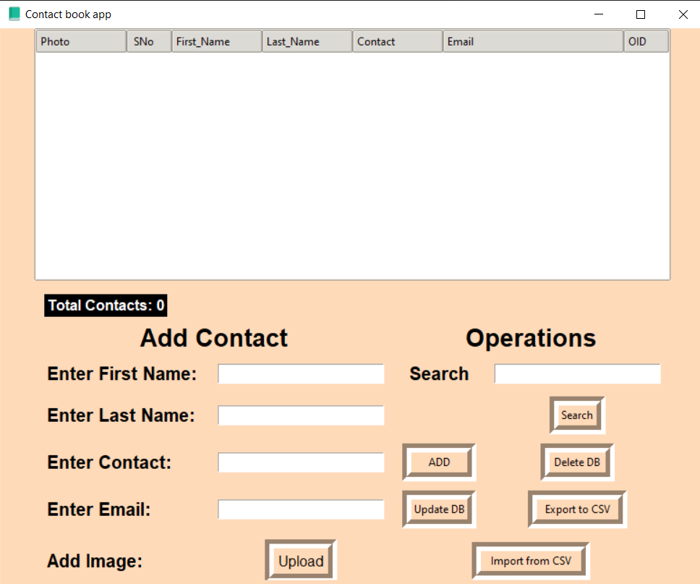

**Searching contacts:**

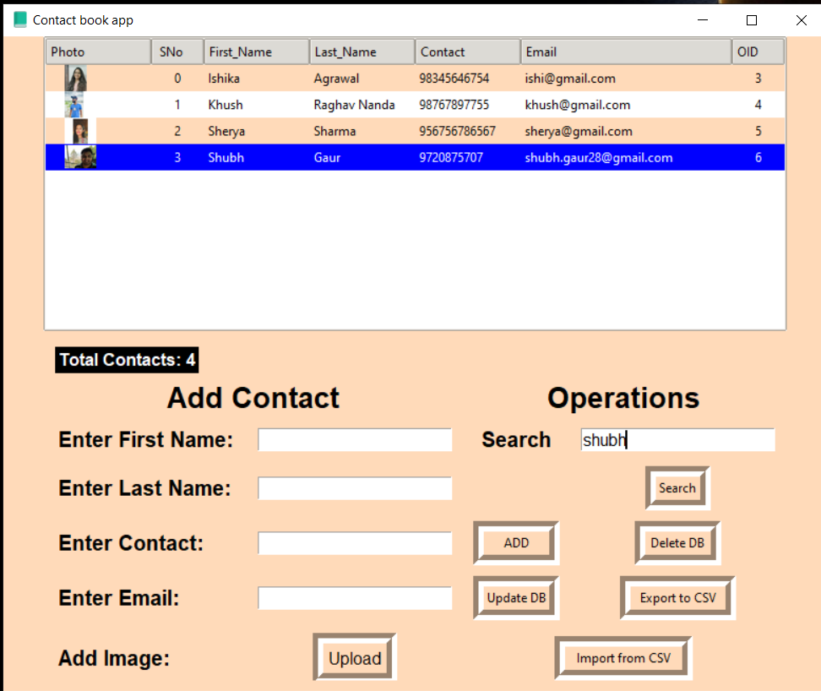

**Update Window:**

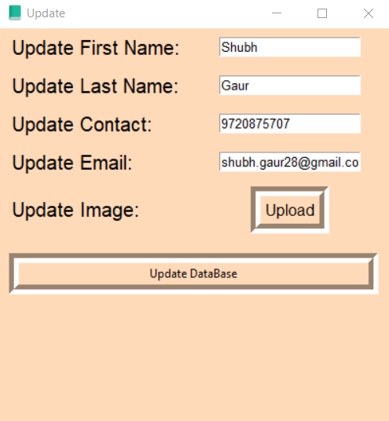

**Conclusion:**

Contact information is a daily use information and major asset of person, business and organization. Contact book database should robust and reliable. Contact book app having a various feature like add, delete, update, search, contact image icon, show total contact in contact book and able to import and export contact information data.

**REFERENCES:**

1. [**https://data-flair.training/blogs/address-book-in-python/**](https://data-flair.training/blogs/address-book-in-python/)
2. [**https://www.researchgate.net/publication/341712729_Design_and_Implementation_of_Online_Address_Book_on_Information_System_Case_Study_of_Personal_Identity**](https://www.researchgate.net/publication/341712729_Design_and_Implementation_of_Online_Address_Book_on_Information_System_Case_Study_of_Personal_Identity)
3. [**https://thecleverprogrammer.com/2021/01/16/contact-book-with-python/**](https://thecleverprogrammer.com/2021/01/16/contact-book-with-python/)
4. [**https://www.tutorialspoint.com/sqlite/sqlite_overview.html**](https://www.tutorialspoint.com/sqlite/sqlite_overview.html)
5. [**https://docs.python.org/3/library/tkinter.html**](https://docs.python.org/3/library/tkinter.html)